IF the path is long, take a taxi.

IF is a conditional statement. If it is greater than 3km, suggest booking a taxi

ELSE, do nothing.

Binary Decision: Booleans

* In hardware: 1 0
* In language: True or False

Program Execution and Flow Control

Programs execute instructions in a sequential Order

Branching is when the algorithm makes a choice.

Programs are Logic.

Selective Statements

IF condition is True

THEN 🡪 do this

Can be represented as flowchart

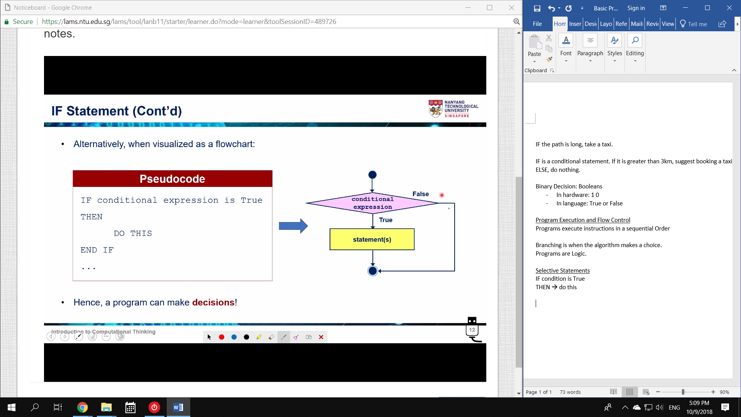

Python Terminology

Python is case sensitive

True/False is capitalized

Statement: Line of code

* Does NOT return a value

\ Backslash – used to indicate same line

# comment – used to ignore lines of code

A program is used to document the thought process of the coder

* Comments should not repeat code

print: displays message and data on the shell

* print() is a line break

Python Interpreter

Determine if syntax is valid

* Eg. Undefined variables are Strings

Syntax:

If <Boolean Expression>

_ _ _ _do a thing

Whitespace

TAB, Space, Enter

Whitespace cannot be placed randomly.

1. Use the same number of spaces for indentation consistently

* Each indentation is a Block

2. Make it more readable

3. Branching and Looping

Advantage of IF:

* The program does not always have to run all the code.

Branching Code

IF ELSE

If True, select A

ELSE, select B (basically, False)

END IF

* Continue executing sequentially

and, or, not

and – both operands are True

or – at least one operand is True

not – invert

Nested IF

Basically just IF inside IF

% 🡪 Modulus (remainder of x/y)

eg.

Today is Tuesday. After 53 days, what day?

53 % 7 = 4

Tuesday + 4 = Saturday

// 🡪 Floor division (integer result)

** 🡪 Exponent

Division by zero gives Error

The computer usually cannot handle mixed data types.

* The computer CAN convert INT to Float (usually)

Order of Operations

()

**

-(x)

*/%

+ -

spam += 2 🡪 spam = spam + 2